**1D Array**.

1. Refer the code snippet and answer the queries.

int main()

{

   int array[100];

   int *ptr;

   // do something

}

Q1. Can pointer be used in Array-style syntax? e.g. ptr[10], ptr[0]

Ans:- yes

Q2. Can Array be used in Pointer-style syntax? e.g *array, (array + 0), *(array + 10)

Ans:- yse

Q3. Is ptr++ valid?

Ans:- yes

Q4. Is array++ valid?

Ans:- No

Q5. What is sizeof(array)?

Ans:- 400

Q6. What is sizeof(ptr)?

Ans:- 8

1. Refer the code snippet below. Comment on the other elements (other than those that are explicitly initialized) of all array variables in  code snippet below.

#define MAX  100

int main()

{

int arr[MAX] = {11,22,33}; // it will assign first 3 values

int arr1[MAX]={0}; // it will assign 0

static int arr2[MAX];

}

1. Refer the program “array_pointer.c”. Add a function getmax() to find the maximum in the array and call in main() and display the result.

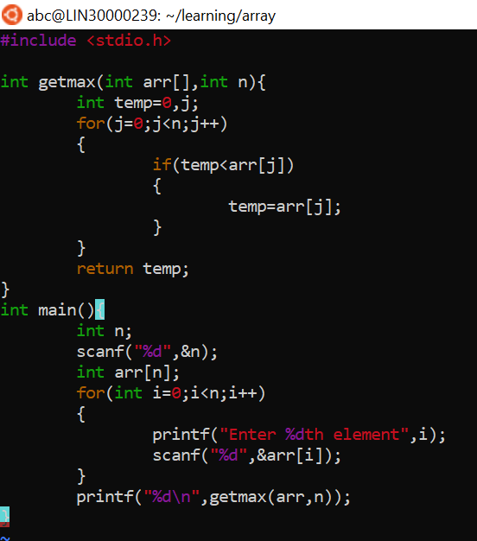

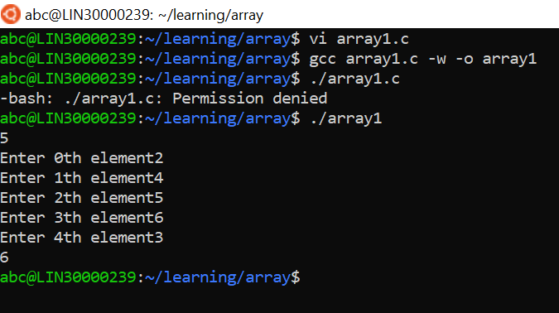

1. Extend the code given below to  read  N  and a start value from the user to perform the given operations.

#define MAX  100

int main()

{

int arr[MAX] = {11,22,33};

}

Add the following functions choosing proper input, output and return.

1. init() - Use the inputs to initialize the  first N elements of the array with N

consequetive values starting with given start value .

1. update() – increment value of every element in the array
2. display() – display the  contents of array

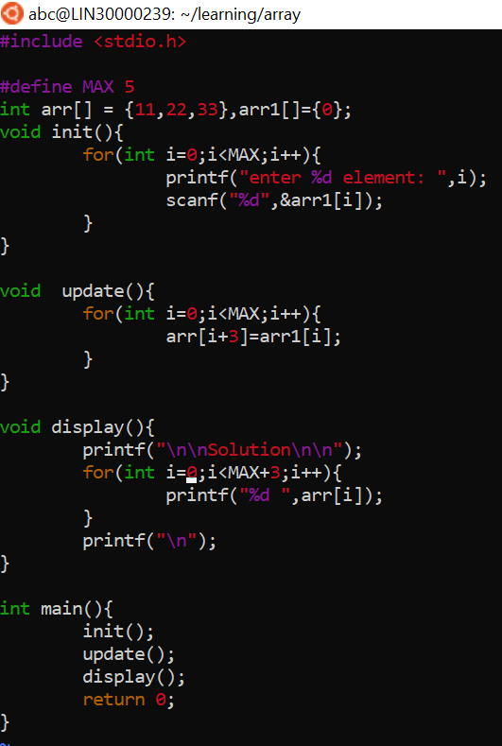

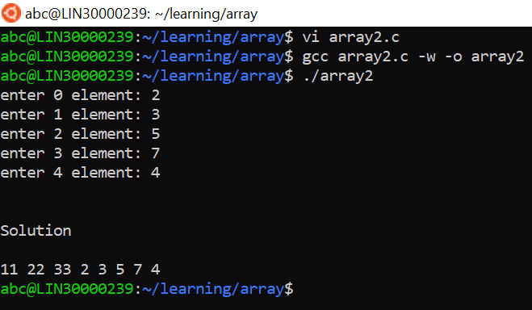

**2D MultiDimensional Arrays**

1. Implement sort() to sort a given array. Refer the code snippet below.

int main()

{

char arr[]= “xaybz”;

sort(arr, sizeof(arr)/sizeof(arr[0]);

return 0;

}

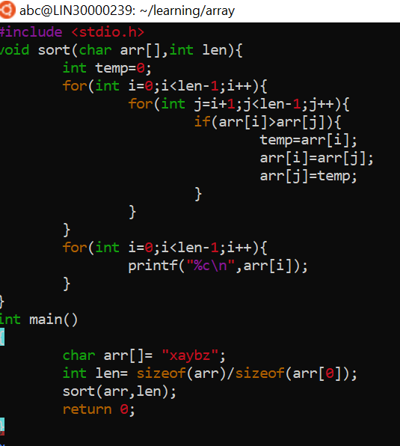

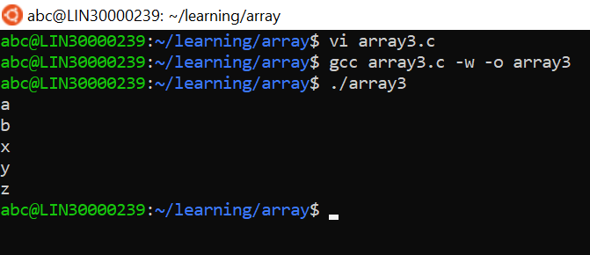

1. Refer the code snippet below.

int main()

{

char arr[][3] = {

sort(arr, sizeof(arr)/sizeof(arr[0]);

return 0;

}

 Allow user to perform the following operations.

1. init() - initialize the array and return 0
2. search_update() – search for a given element in array and  if found update it to given value and return 0 else return 1
3. display() – traverse and display array contents

For the functions, pass array and other required arguments to functions and return as  per requirement

